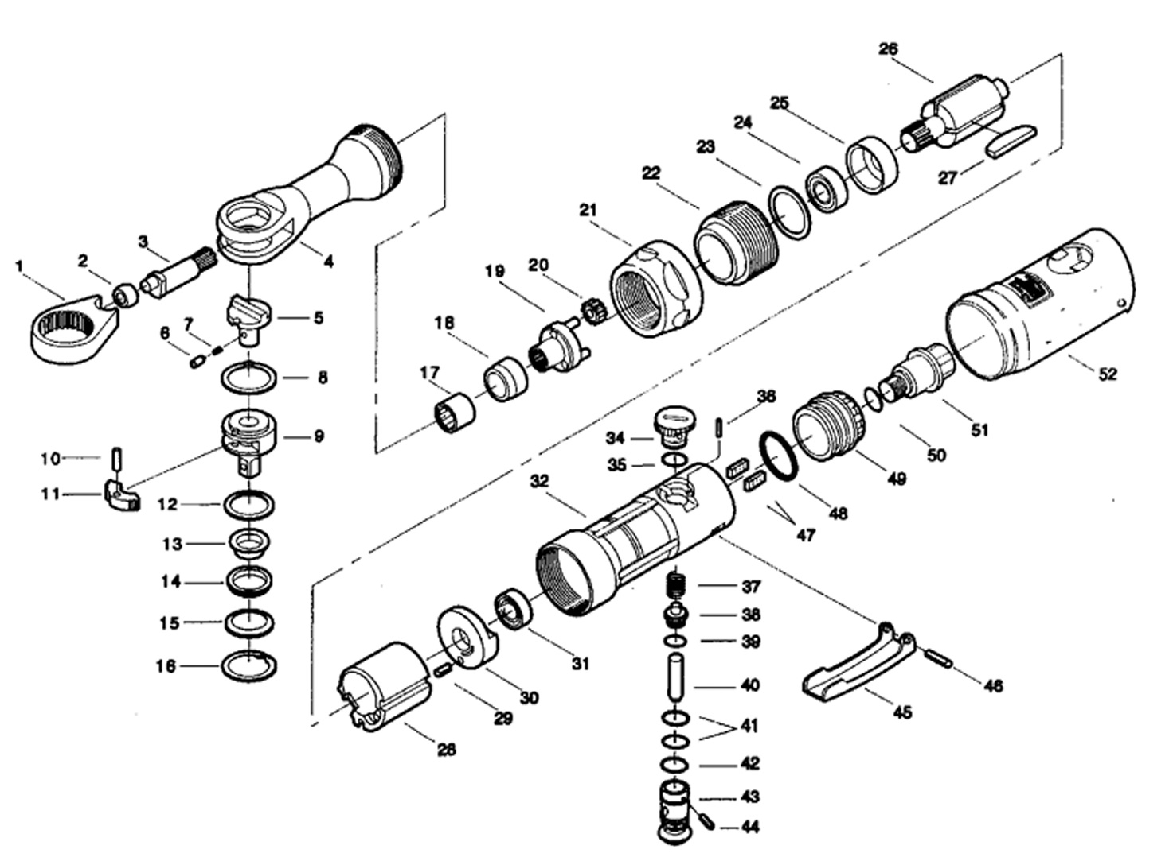

**GP1912**

**Clé à rochet 1/4**

|  |  |  |  |  |  |  |  |
| --- | --- | --- | --- | --- | --- | --- | --- |
| Rep | REF. NO. | DESCRIPTION | QTE | Rep. | REF. NO. | DESCRIPTION | QTE |
| 1 | GP1912-01 | Engrenage tête | 1 | 27 | GP1912-27 | Palette | 4 |
| 2 | GP1912-02 | Rochet | 1 | 28 | GP1912-28 | Chemise | 1 |
| 3 | GP1912-03 | Axe rochet | 1 | 29 | GP1912-29 | Goupille | 1 |
| 4 | GP1912-04 | Carter tête | 1 | 30 | GP1912-30 | Flasque arrière | 1 |
| 5 | GP1912-05 | Bouton inverseur | 1 | 31 | 696-2RS | Roulement 696 | 1 |
| 6 | GP1912-06 | Axe | 1 | 32 | GP1912-32 | Corps | 1 |
| 7 | GP1912-07 | Ressort | 1 | 34 | GP1912-34 | Joint | 1 |
| 8 | GP1912-08 | Rondelle | 1 | 35 | GP1912-35 | Inverseur | 1 |
| 9 | GP1912-09 | Carré 1/4 | 1 | 36 | GP1912-36 | Goupille | 1 |
| 10 | GP1912-10 | Axe | 1 | 37 | GP1912-37 | Ressort | 1 |
| 11 | GP1912-11 | Pignon | 1 | 38 | GP1912-38 | Valve | 1 |
| 12 | GP1912-12 | Rondelle | 1 | 39 | GP1912-39 | Joint | 1 |
| 13 | GP1912-13 | Entretoise | 1 | 40 | GP1912-40 | Axe | 1 |
| 14 | GP1912-14 | Rondelle | 1 | 41 | GP1912-41 | Joint | 2 |
| 15 | GP1912-15 | Rondelle | 1 | 42 | GP1912-42 | Joint | 1 |
| 16 | GP1912-16 | Circlips | 1 | 43 | GP1912-43 | Régulateur | 1 |
| 17 | GP1912-17 | Roulement aiguille | 1 | 44 | GP1912-44 | Axe | 1 |
| 18 | GP1912-18 | Entretoise | 1 | 45 | GP1912-45 | Gâchette | 1 |
| 19 | GP1912-19 | Porte satellite | 1 | 46 | GP1912-46 | Axe | 1 |
| 20 | GP1912-20 | Satellite | 3 | 47 | GP1912-47 | Mousse | 2 |
| 21 | GP1912-21 | Ecrou serrage | 1 | 48 | GP1912-48 | Joint | 2 |
| 22 | GP1912-22 | Bague | 1 | 49 | GP1912-49 | Echappement | 1 |
| 23 | GP1912-23 | Rondelle | 1 | 50 | GP1912-50 | Joint | 1 |
| 24 | 608-2RS | Roulement 608 | 1 | 51 | GP1912-51 | Raccord | 1 |
| 25 | GP1912-25 | Flasque avant | 1 | 52 | GP1912-52 | Gaine plastique | 1 |
| 26 | GP1912-26 | Rotor | 1 |  |  |  |  |