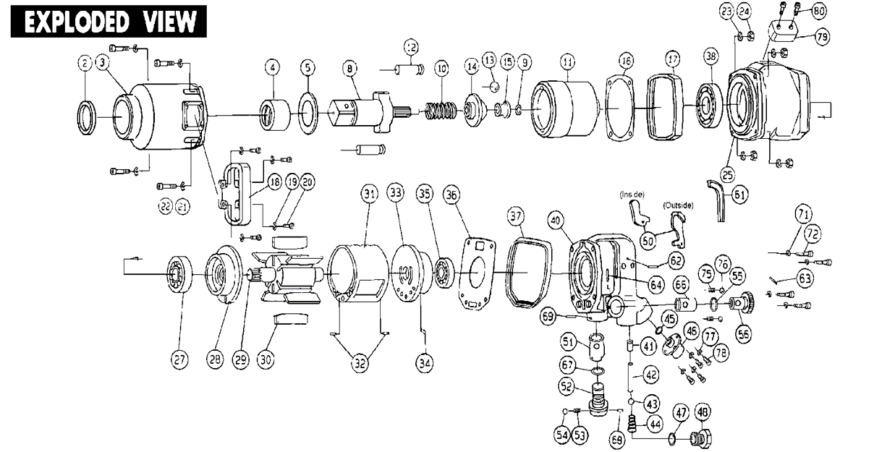

**GP1795**

**Clé à chocs 1-1/2’’**

|  |  |  |  |  |  |  |  |
| --- | --- | --- | --- | --- | --- | --- | --- |
| Rep | Référence | Désignation | qté | Rep | Référence | Désignation | qté |
| 2 | GP1795-02 | Joint spy | 1 | 38 | 6010-2RS | Roulement 6010 | 1 |
| 3 | GP1795-03 | Cloche ASS | 1 | 40 | GP1795-40 | Poignée arrière ASS | 1 |
| 4 | GP1795-04 | Entretoise | 1 | 41 | GP1795-41 | Insert | 1 |
| 5 | GP1795-05 | Rondelle | 1 | 42 | GP1795-42 | Axe | 1 |
| 8 | GP1795-08 | Broche | 1 | 43 | GP1795-43 | Bille | 1 |
| 9 | GP1795-09 | Circlips | 1 | 44 | GP1795-44 | Ressort | 1 |
| 10 | GP1795-10 | Ressort | 1 | 45 | GP1795-45 | Joint | 1 |
| 11 | GP1795-11 | Cage de frappe | 1 | 46 | GP1795-46 | Raccord | 1 |
| 12 | GP1795-12 | Marteau | 2 | 47 | GP1795-47 | Joint | 1 |
| 13 | GP1795-13 | Bille | 1 | 48 | GP1795-48 | Écrou | 1 |
| 14 | GP1795-14 | Came | 1 | 51 | GP1795-51 | Chemise | 1 |
| 15 | GP1795-15 | Cuvette bille | 1 | 52 | GP1795-52 | Inverseur ASS | 1 |
| 16 | GP1795-16 | joint | 1 | 53 | GP1795-53 | Ressort | 1 |
| 17 | GP1795-17 | Protection caoutchouc | 1 | 54 | GP1795-54 | Bille | 1 |
| 18 | GP1795-18 | Poignée | 1 | 55 | GP1795-55 | Joint | 1 |
| 19 | GP1795-19 | Rondelle | 4 | 56 | GP1795-56 | Ajust Valve | 1 |
| 20 | GP1795-20 | Vis | 4 | 60 | GP1795-60 | Gâchette | 1 |
| 21 | GP1795-21 | Rondelle | 4 | 61 | GP1795-61 | Caoutchouc | 1 |
| 22 | GP1795-22 | Écrou | 4 | 62 | GP1795-62 | Goupille | 1 |
| 23 | GP1795-23 | Rondelle | 4 | 63 | GP1795-63 | Goupille | 1 |
| 24 | GP1795-24 | Écrou | 4 | 64 | GP1795-64 | Goupille | 1 |
| 25 | GP1795-25 | Carter moteur | 1 | 66 | GP1795-66 | Chemise | 1 |
| 27 | 6206-2RS | Roulement 6206Z | 1 | 67 | GP1795-67 | Joint | 1 |
| 28 | GP1795-28 | Flasque avant | 1 | 68 | GP1795-68 | Goupille | 1 |
| 29 | GP1795-29 | Rotor | 1 | 69 | GP1795-69 | Goupille | 1 |
| 30 | GP1795-30 | Palette | 6 | 71 | GP1795-71 | Rondelle | 4 |
| 31 | GP1795-31 | Chemise ASS | 1 | 72 | GP1795-72 | Vis | 4 |
| 32 | GP1795-32 | Goupille | 2 | 75 | GP1795-75 | Ressort | 2 |
| 33 | GP1795-33 | Flasque arrière ASS | 1 | 76 | GP1795-76 | Bille | 2 |
| 34 | GP1795-34 | Goupille | 1 | 77 | GP1795-77 | Rondelle | 4 |
| 35 | 6205-2RS | Roulement 6205 | 1 | 78 | GP1795-78 | Vis | 4 |
| 36 | GP1795-36 | Joint | 1 | 79 | GP1795-79 | Échappement | 1 |
| 37 | GP1795-37 | Protection caoutchouc | 1 | 80 | GP1795-80 | Vis | 2 |