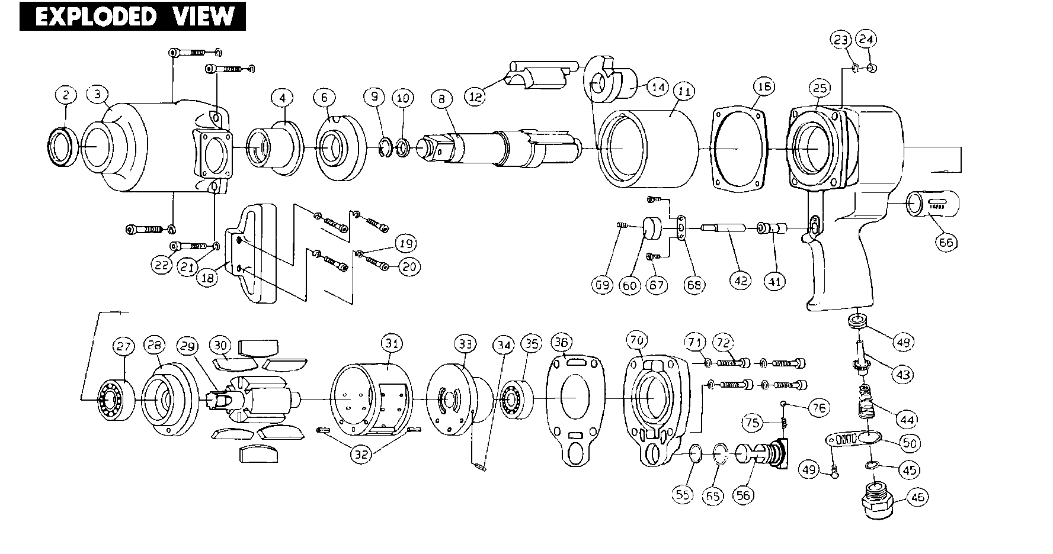

**GP1599 – GP1599L**

**Clé à chocs 1’’**

|  |  |  |  |  |  |  |  |
| --- | --- | --- | --- | --- | --- | --- | --- |
| Ref | Rep | Désignation | qty | Ref | Rep | Désignation | PER SET |
| GP 1599-45 | 2 | Joint spy | 1 | GP 1599-23 | 33 | Flasque arrière assemblé | 1 |
| GP 1599-43 | 3 | cloche assemblé | 1 | GP 1599-24 | 34 | Goupille | 1 |
| GP 1599-44 | 4 | Entretoise | 1 | 6204-2RS | 35 | Roulement 6204 | 1 |
| GP 1599-39 | 6 | Rondelle cage de frappe | 1 | GP 1599-26 | 36 | Joint carter arr | 1 |
| GP 1599-40 | 8 | Broche courte assemblé | 1 | GP 1599-4 | 41 | Chemise gâchette | 1 |
| GP 1599-40A | Broche longue assemblé | 1 | GP 1599-9 | 42 | Axe gâchette | 1 |
| RA1253 | 9 | Circlips | 1 | GP 1599-13 | 43 | Valve | 1 |
| GP 1599-42 | 10 | joint | 1 | GP 1599-14 | 44 | Ressort | 1 |
| GP 1599-36 | 11 | cage de frappe | 1 | GP 1599-16 | 45 | Joint | 1 |
| GP 1599-38 | 12 | Marteau | 1 | GP 1599-15 | 46 | Raccord | 1 |
| GP 1599-37 | 14 | Came | 1 | GP 1599-3 | 48 | Joint valve | 1 |
| GP 1599-35 | 16 | Joint cloche | 1 | GP 1599-12 | 49 | Vis | 1 |
| GP 1599-46 | 18 | Poigné latérale | 1 | GP 1599-10 | 50 | Echappement | 1 |
| GP 1599-48 | 19 | Rondelle | 4 | GP 1599-31 | 55 | Joint | 1 |
| GP 1599-47 | 20 | Vis | 4 | GP 1599-28 | 56 | Regulateur inverseur | 1 |
| GP 1599-50 | 21 | Rondelle | 4 | GP 1599-5 | 60 | Gâchette | 1 |
| GP 1599-49 | 22 | Vis | 4 | GP 1599-32 | 65 | Circlips | 1 |
| GP 1599-50 | 23 | Rondelle | 4 | GP 1599-2 | 66 | Chambre inverseur | 1 |
| GP 1599-51 | 24 | Ecrou | 4 | GP 1599-8 | 67 | Vis | 2 |
| GP 1599-01 | 25 | Corps moteur assemblé | 1 | GP 1599-7 | 68 | Plaque | 1 |
| 6205-2RS | 27 | Roulement 6205 | 1 | GP 1599-6 | 69 | Vis gâchette | 1 |
| GP 1599-18 | 28 | Flasque avant | 1 | GP 1599-27 | 70 | Capot arriere | 1 |
| GP 1599-19 | 29 | Rotor | 1 | GP 1599-34 | 71 | Rondelle | 4 |
| GP 1599-20 | 30 | Palette | 6 | GP 1599-33 | 72 | Vis carter | 4 |
| GP 1599-21 | 31 | Chemise assemblé | 1 | GP 1599-30 | 75 | Ressort | 1 |
| GP 1599-22 | 32 | Goupille | 2 | GP 1599-29 | 76 | Bille | 1 |