**GP1595 – GP1595L**

**Clé à chocs 1’’**

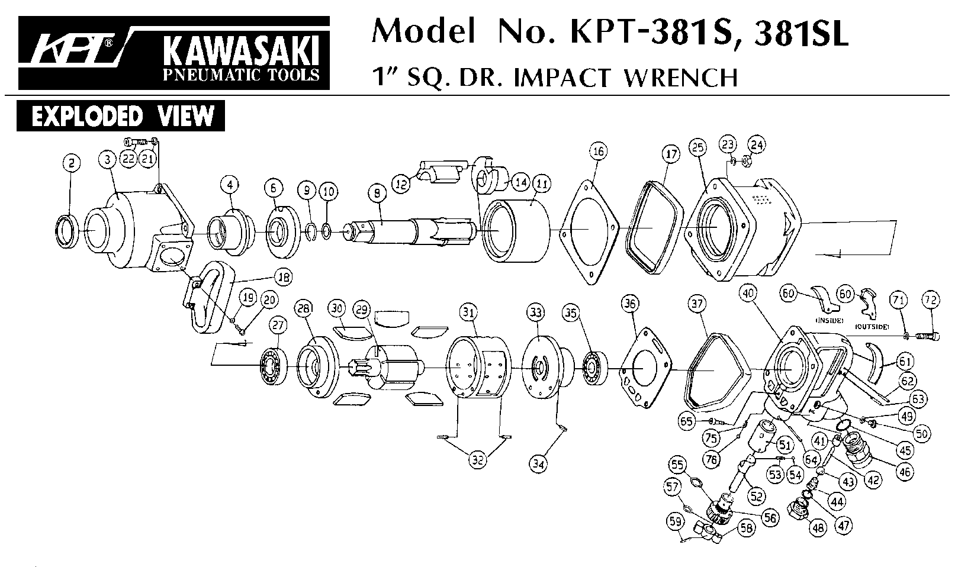

|  |  |  |  |  |  |  |  |
| --- | --- | --- | --- | --- | --- | --- | --- |
| rep. | Référence | Désignation | Qty | rep. | Référence | Désignation | Qty |
| 2 | GP 1595-02 | Joint spy | 1 | 37 | GP 1595P-37 | Protection caoutchouc | 1 |
| 3 | GP 1595-03 | Cloche | 1 | 40 | GP 1595P-40 | Poignée arrière | 1 |
| 4 | GP 1595-04 | Entretoise cloche | 1 | 41 | GP 1595P-41 | Entretoise | 1 |
| 6 | GP 1595-06 | Rondelle cage | 1 | 42 | GP 1595P-42 | Axe valve | 1 |
| 8 | GP 1595L-08 | Broche longue | 1 | 43 | GP 1595P-43 | Valve | 1 |
| GP 1595-08 | Broche courte | 1 | 44 | GP 1595P-44 | Ressort | 1 |
| 9 | RA1253 | Jonc | 1 | 45 | GP 1595P-45 | Joint | 1 |
| 10 | RA1353 | Joint | 1 | 46 | GP 1595P-46 | Raccord | 1 |
| 11 | GP 1595P-11 | Cage de frappe | 1 | 47 | GP 1595P-47 | Joint | 1 |
| 12 | GP 1595P-12 | Marteau | 1 | 48 | GP 1595P-48 | Ecrou | 1 |
| 14 | GP 1595P-14 | Came | 1 | 49 | GP 1595P-49 | Joint | 1 |
| 16 | GP 1595P-16 | Joint Cloche | 1 | 50 | GP 1595P-50 | Graisseur | 1 |
| 17 | GP 1595P-17 | Protection caoutchouc | 1 | 51 | GP 1595P-51 | Insert | 1 |
| 18 | GP 1599-46 | Poignée | 1 | 52 | GP 1595P-52 | Axe inverseur | 1 |
| 19 | GP 1599-48 | Rondelle | 4 | 53 | GP 1595P-53 | Ressort | 1 |
| 20 | GP 1599-49 | Ecrou | 4 | 54 | GP 1595P-54 | Bille | 1 |
| 21 | GP 1595P-21 | Rondelle | 4 | 55 | GP 1595P-55 | Joint | 1 |
| 22 | GP 1595P-22 | Ecrou | 4 | 56 | GP 1595P-56 | Bouton régulateur | 1 |
| 23 | GP 1595P-23 | Rondelle | 4 | 57 | GP 1595P-57 | Joint | 1 |
| 24 | GP 1595P-24 | Boulon | 4 | 58 | GP 1595P-58 | Bouton inverseur | 1 |
| 25 | GP 1595P-25 | Carter moteur | 1 | 59 | GP 1595P-59 | Goupille | 1 |
| 27 | 6205-2RS | Roulement 6205 | 1 | 60 | GP 1595P-60 | Gâchette | 1 |
| 28 | GP 1595P-28 | Flasque avant | 1 | 61 | GP 1595P-61 | Caoutchouc protection | 1 |
| 29 | GP 1595P-29 | Rotor | 1 | 62 | GP 1595P-62 | Goupille | 1 |
| 30 | GP 1599-20 | Palette | 5 | 63 | GP 1595P-63 | Goupille | 1 |
| 31 | GP 1595P-31A | Chemise avec goupille | 1 | 64 | GP 1595P-64 | Goupille | 1 |
| 32 | GP 1595P-32 | Goupille | 2 | 65 | GP 1595P-65 | Ecrou | 1 |
| 33 | GP 1595P-33A | Flasque arrière avec goupille | 1 | 71 | GP 1595P-71 | Rondelle | 4 |
| 34 | GP 1595-34 | Goupille | 1 | 72 | GP 1595P-72 | Vis | 4 |
| 35 | 6204-2RS | Roulement 6204 | 1 | 75 | GP 1595P-75 | Ressort | 1 |
| 36 | GP 1595P-36 | Joint moteur arr | 1 | 76 | GP 1595P-76 | Bille | 1 |