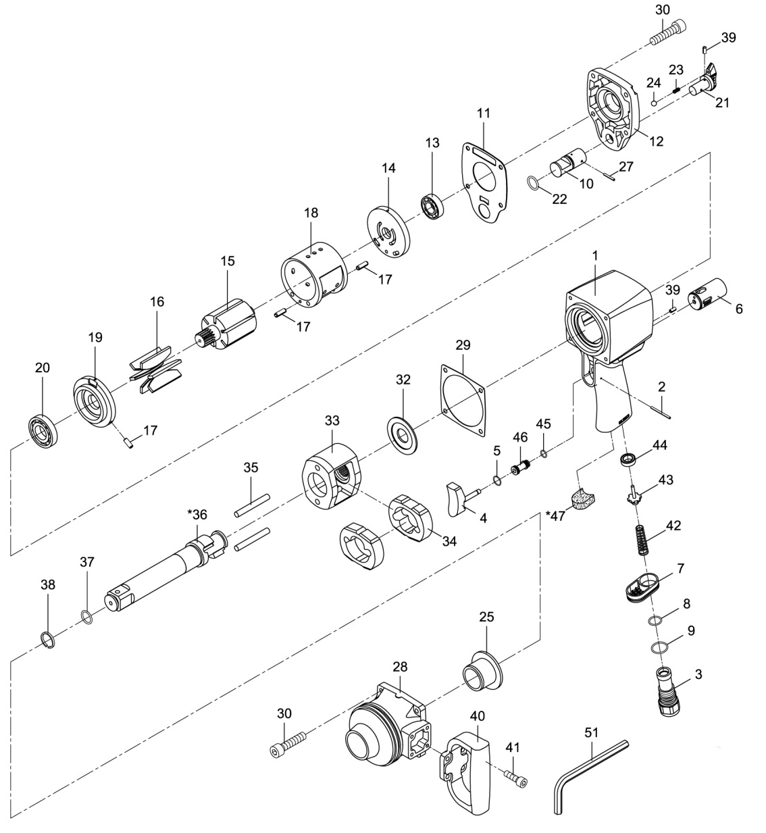

**GP1563**

**Clé à chocs 1’’**

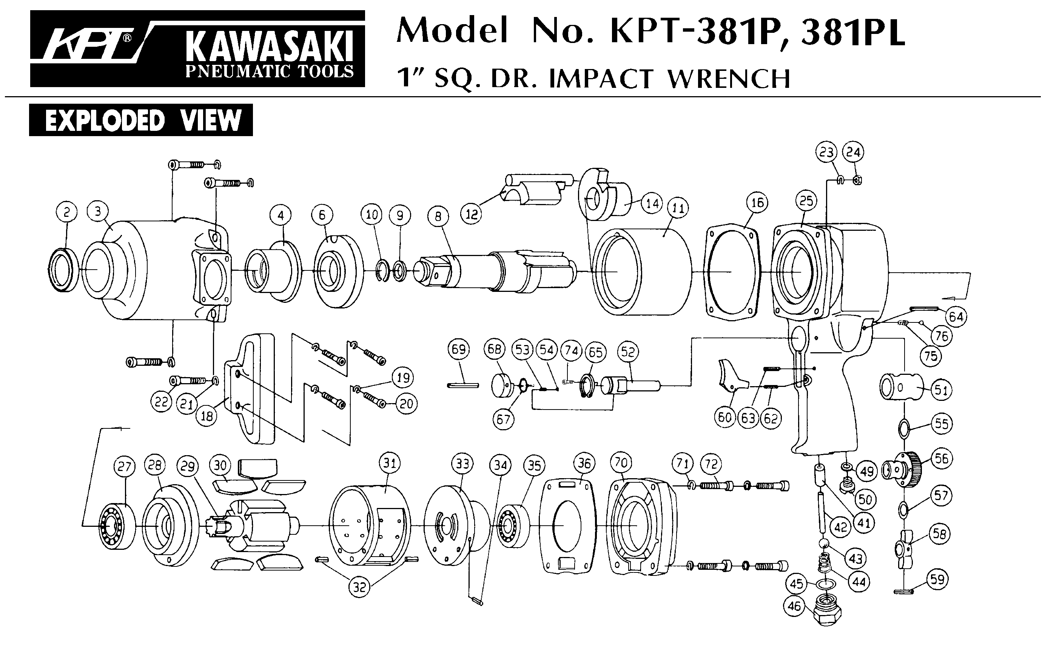





|  |  |  |  |  |  |  |  |
| --- | --- | --- | --- | --- | --- | --- | --- |
| ref. | Rep | Désignation | Qté | ref. | Rep | Désignation | Qté |
| GP1563-1 | 1 | Corps | 1 | GP1563KITB | 11 | Joint | 1 |
| GP1563KITA | 2 | Goupille | 1 | 13 | Roulement Arr | 1 |
| 3 | Raccord | 1 | 16 | Palette | 6 |
| 4 | Gâchette | 1 | 20 | Roulement Avt | 1 |
| 5 | Joint | 1 | 29 | Joint | 1 |
| 7 | Echappement | 1 | 30 | Vis | 8 |
| 8 | Joint | 1 | GP1563KITC | 32 | Rondelle | 1 |
| 9 | Joint | 1 | 33 | Cage de frappe | 1 |
| 10 | Inverseur | 1 | 34 | Marteau | 2 |
| 21 | Bouton régulateur | 1 | 35 | Axe marteau | 2 |
| 22 | Joint | 1 | 36 | Broche | 1 |
| 23 | Ressort | 1 | 37 | Joint | 1 |
| 24 | Bille | 1 | 38 | Jonc | 1 |
| 27 | Goupille | 1 | GP1563KITD | 14 | Flasque Arrière | 1 |
| 39 | Goupille | 2 | 15 | Rotor | 1 |
| 42 | Ressort | 1 | 17 | Goupille | 3 |
| 43 | Valve | 1 | 18 | Chemise moteur | 1 |
| 44 | joint | 1 | 19 | Flasque avant | 1 |
| 45 | Joint | 1 | GP1593KITG | 40 | Poignée | 1 |
| 46 | Chemise gâchette | 1 | 41 | Vis | 4 |
| GP1563-6 | 6 | Chambre d’inverseur | 1 | 51 | clé 5mm | 1 |
| GP1563-12 | 12 | Carter arrière | 1 | GP1563-28 | 28 | Cloche | 1 |
| GP1563-25 | 25 | Entretoise cloche | 1 | GP1563-47 | 47 | Mousse poignée | 1 |

**Manche Atlantique Equipements** -27 parc d’activité du Chalet - 22250 BroonsTél 02 96 84 65 59 - Fax 02 96 84 77 75

**WWW.MAE-FR.COM**