

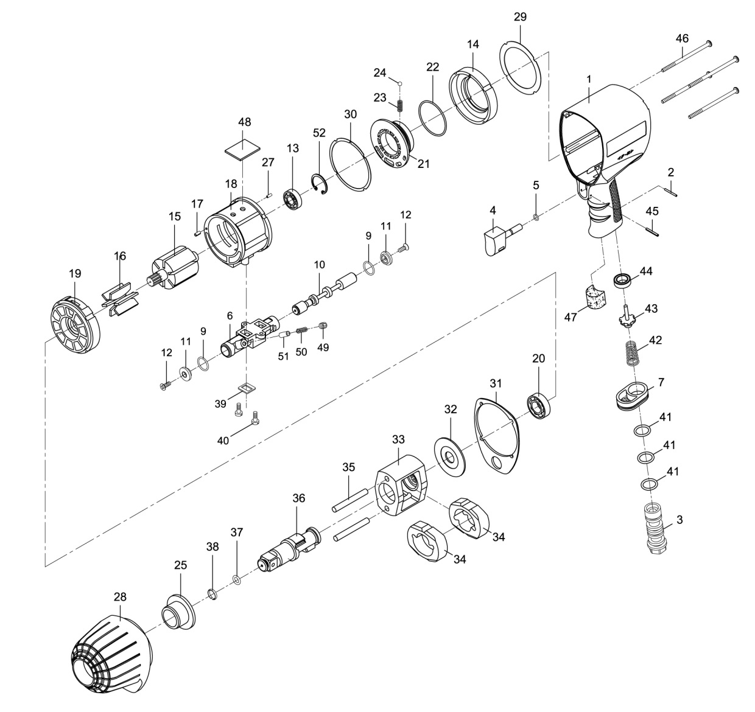

**GP1493**

**Clé à chocs 3/4’’**

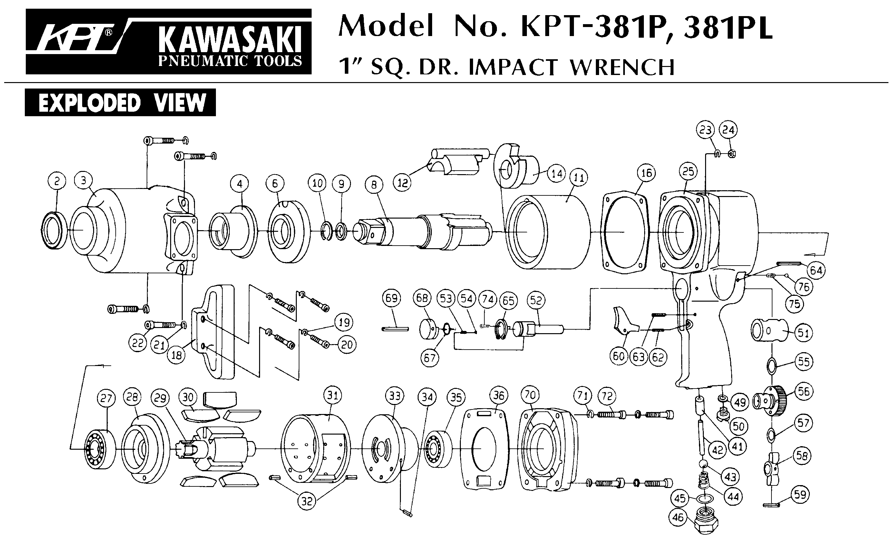





|  |  |  |  |  |  |  |  |
| --- | --- | --- | --- | --- | --- | --- | --- |
| ref. | Rep | Désignation | Qté | ref. | Rep | Désignation | Qté |
| GP1493-1 | 1 | Corps | 1 | GP1493-14 | 14 | Entretoise | 1 |
| GP1493KITA | 2 | Goupille | 1 | GP1493KITC | 32 | Rondelle | 1 |
| 3 | Raccord | 1 | 33 | Cage de frappe | 1 |
| 4 | Gâchette | 1 | 34 | Marteau | 2 |
| 5 | Joint | 1 | 35 | Axe marteau | 2 |
| 7 | Echappement | 1 | 36 | Broche | 1 |
| 41 | joint | 3 | 37 | Joint | 1 |
| 42 | Ressort | 1 | 38 | Jonc | 1 |
| 43 | Valve | 1 | GP1493KITD | 15 | Rotor | 1 |
| 44 | joint | 1 | 18 | Chemise moteur (+ flasque Arr) | 1 |
| 45 | Goupille | 1 | 19 | Flasque avt | 1 |
| 47 | Mousse poignée | 1 | GP1493KITE | 6 | Chambre d’inverseur | 1 |
| GP1493KITB | 13 | Roulement Arr | 1 | 9 | Joint inverseur avt | 2 |
| 16 | Palette | 6 | 10 | Inverseur | 1 |
| 17 | Goupille | 1 | 11 | Embout inverseur | 2 |
| 20 | Roulement Avt | 1 | 12 | Vis | 2 |
| 22 | Joint | 1 | 39 | Joint | 1 |
| 23 | Ressort | 1 | 40 | vis | 2 |
| 24 | Bille | 1 | 49 | Vis | 1 |
| 27 | Goupille | 1 | 50 | Ressort | 1 |
| 29 | Joint | 1 | 51 | retenue | 1 |
| 30 | Joint | 1 | GP1493-21 | 21 | Régulateur | 1 |
| 31 | Joint | 1 | GP1493-25 | 25 | Entretoise cloche | 1 |
| 46 | vis | 4 | GP1493-28 | 28 | Cloche | 1 |
| 52 | Circlips | 1 | GP1493-48 | 48 | Mousse moteur | 1 |

**Manche Atlantique Equipements** -27 parc d’activité du Chalet - 22250 BroonsTél 02 96 84 65 59 - Fax 02 96 84 77 75

**WWW.MAE-FR.COM**