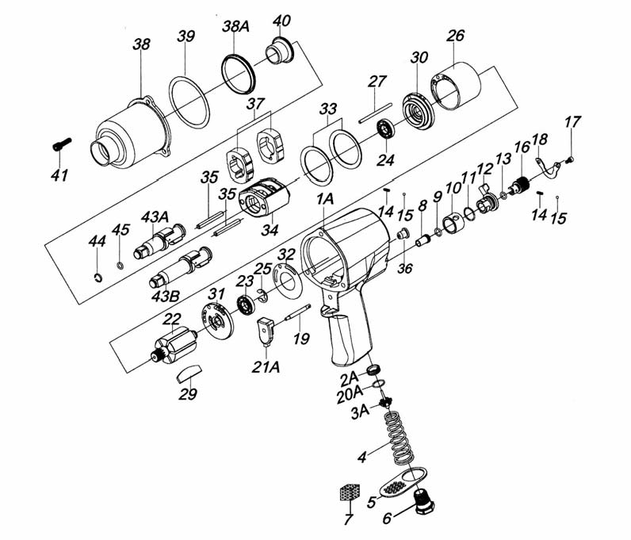

**GP1345**

**Clé à chocs 1/2**

|  |  |  |  |  |  |  |  |
| --- | --- | --- | --- | --- | --- | --- | --- |
| Ref . | Rep | Désignation | Qté | Ref . | Rep | Désignation | Qté |
| GP1345-01A | 1A | Corps moteur avec (8-9-10) | 1 | GP1345-25 | 25 | Circlips | 1 |
| GP1345- 02A | 2A | Joint fond | 1 | GP1345-26 | 26 | Chemise | 1 |
| GP1345-03A | 3A | Valve | 1 | GP1345-27 | 27 | Axe chemise | 1 |
| GP1345-04 | 4 | Ressort | 1 | GP1345-29 | 29 | Palette | 6 |
| GP1345-05 | 5 | Déflecteur air | 1 | GP1345-30 | 30 | Flasque Avt | 1 |
| GP1345-06 | 5 | Raccord | 1 | GP1345-31 | 31 | Flasque Arre | 1 |
| GP1345-07 | 7 | Silencieux | 1 | GP1345-32 | 32 | Joint flasque Arr | 1 |
| GP1345-08 | 8 | Guide | 1 | GP1345-33 | 33 | Rondelle calage moteur | 2 |
| GP1345-09 | 9 | Joint | 1 | GP1345-34 | 34 | Cage de frappe | 1 |
| GP1345-10 | 10 | Chambre Inverseur | 1 | GP1345-35 | 35 | Axe Marteau | 2 |
| GP1345-11 | 11 | Joint | 1 | GP1345-36 | 36 | Grease Fitting | 1 |
| GP1345-12 | 12 | Inverseur | 1 | GP1345-37 | 37 | Marteau | 2 |
| GP1345-13 | 13 | Joint | 1 | GP1345-38 | 38 | Carter cage de frappe | 1 |
| GP1345-14 | 14 | Ressort | 2 | GP1345-38A | 38A | Bague | 1 |
| GP1345-15 | 15 | Billel | 2 | GP1345-39 | 39 | Joint cloche | 1 |
| GP1345-16 | 16 | Bouton variateur | 1 | GP1345-40 | 40 | Entretoise cloche | 1 |
| GP1345-17 | 17 | Vis | 2 | GP1345-41 | 41 | Vis | 3 |
| GP1345-18 | 18 | Retenue variateurr | 1 | GP1345-43A | 43A | Broche | 1 |
| GP1345-19 | 19 | Axe gâchette | 1 | RA1251 | 44 | Jonc 1/2r | 1 |
| GP1345-20A | 20A | Joint | 1 | RA1350 | 45 | Joint | 1 |
| GP1345-21A | 21A | Gâchetter | 1 |  |  |  |  |
| GP1345-22 | 22 | Rotor | 1 | GP1345-TK |  | Kit joint-jonc | |
| 6001-2RS | 23 | Roulement Arr 6001 | 1 |  |  | INC.9,11,13,20A,32,39,44,45 |  |
| 6002-2rs | 24 | Roulement Avt 6002 | 1 |  |  |  |  |