

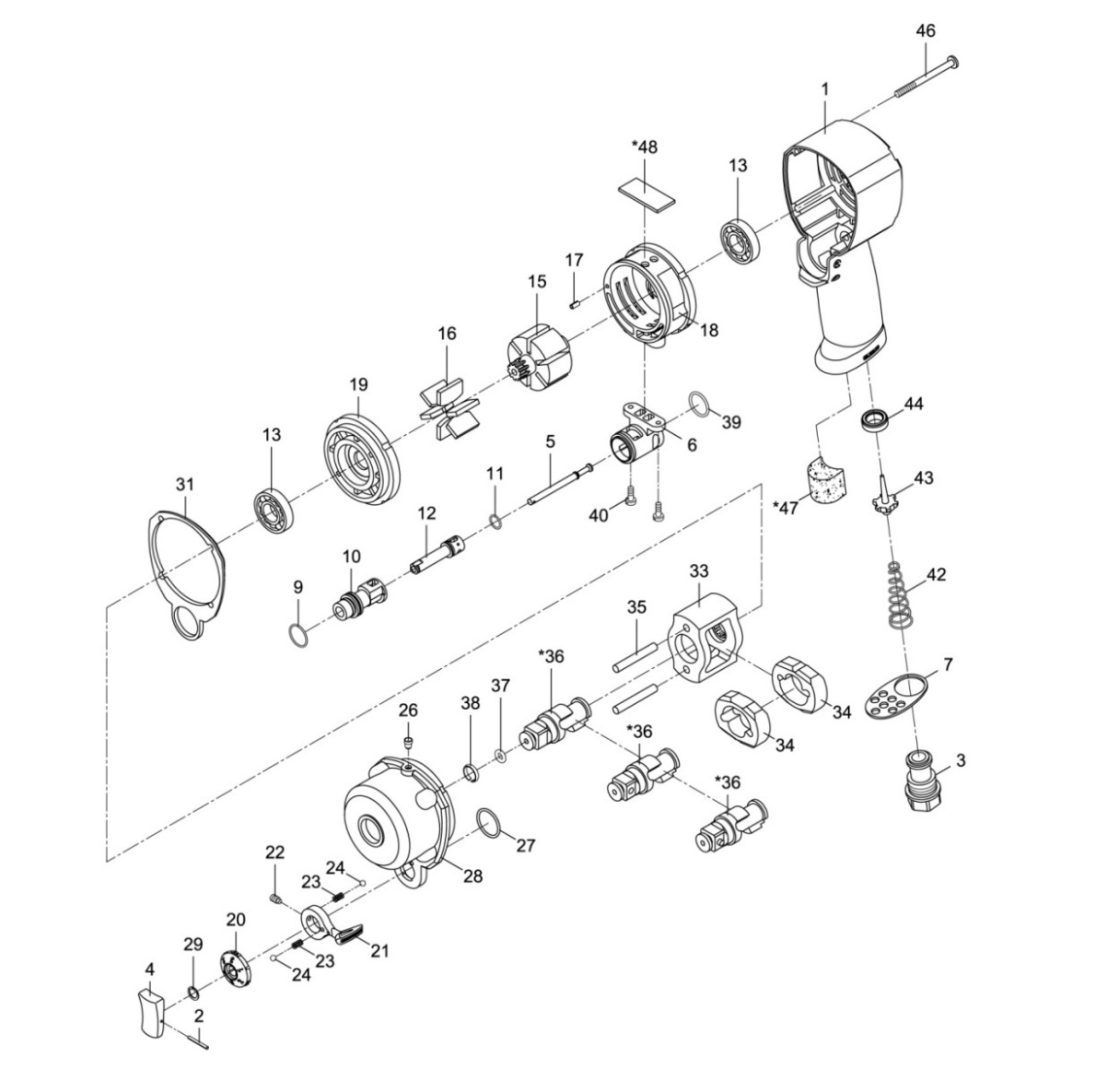

**GP1303**

**Clé à chocs 1/2**

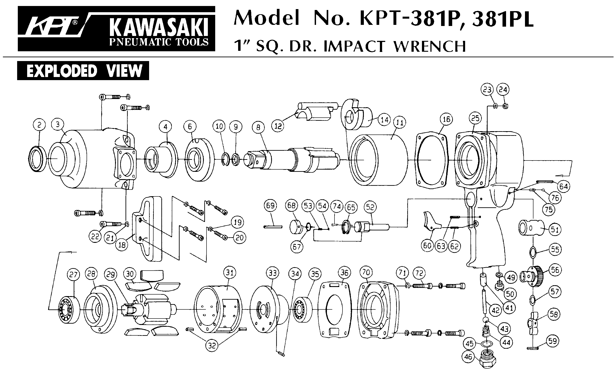





|  |  |  |  |  |  |  |  |  |  |
| --- | --- | --- | --- | --- | --- | --- | --- | --- | --- |
| ref. | Rep | ref. | Désignation | Qté | ref. | Rep | ref. | Désignation | Qté |
| GP1303KITA | 2 | GP1303-2 | Goupille | 1 | GP1303KITD | 6 | GP1303-6 | Chambre d’inverseur | 1 |
| 3 | GP1303-3 | Raccord | 1 | 15 | GP1303-15 | Rotor | 1 |
| 4 | GP1303-4 | Gâchette | 1 | 18 | GP1303-18 | Chemise moteur (avec flasque Arr) | 1 |
| 5 | GP1303-5 | Axe | 1 | 19 | GP1303-19 | Flasque avt | 1 |
| 7 | GP1303-7 | Echappement | 1 | 40 | GP1303-40 | vis | 2 |
| 9 | GP1303-9 | Joint inverseur avt | 1 | GP1303KITC | 33 | GP1303-33 | Cage de frappe | 1 |
| 11 | GP1303-11 | Joint | 1 | 34 | GP1303-34 | Marteau | 2 |
| 20 | GP1303-20 | Molette vitesse | 1 | 35 | GP1303-35 | Axe marteau | 2 |
| 21 | GP1303-21 | Molette inverseur | 1 | 36 | GP1303-36 | Broche | 1 |
| 22 | GP1303-22 | Vis | 1 | 37 | GP1303-37 | Joint | 1 |
| 23 | GP1303-23 | Ressort | 2 | 38 | GP1303-38 | Jonc | 1 |
| 24 | GP1303-24 | Bille | 2 | GP1303KITB | 13 | GP1303-13 | Roulement moteur EE4 | 2 |
| 27 | GP1303-27 | Joint | 1 | 16 | GP1303-16 | Palette | 6 |
| 29 | GP1303-29 | clips | 1 | 17 | GP1303-17 | Goupille | 1 |
| 39 | GP1303-39 | Joint | 1 | 31 | GP1303-31 | Joint | 1 |
| 42 | GP1303-42 | Ressort | 1 | 46 | GP1303-46 | vis | 4 |
| 43 | GP1303-43 | Valve | 1 | GP1303-12 | 12 | GP1303-12 | Axe variateur | 1 |
| 44 | GP1303-44 | joint | 1 | GP1303-26 | 26 | GP1303-26 | Huileur | 1 |
| 47 | GP1303-47 | Mousse poignée | 1 | GP1303-28 | 28 | GP1303-28 | Cloche | 1 |
| GP1303-1 | 1 | GP1303-1 | Corps | 1 | GP1303-48 | 48 | GP1303-48 | Mousse moteur | 1 |
| GP1303-10 | 10 | GP1303-10 | Valve inverseur | 1 |  |  |  |  |  |

**Manche Atlantique Equipements** -27 parc d’activité du Chalet - 22250 BroonsTél 02 96 84 65 59 - Fax 02 96 84 77 75

**WWW.MAE-FR.COM**