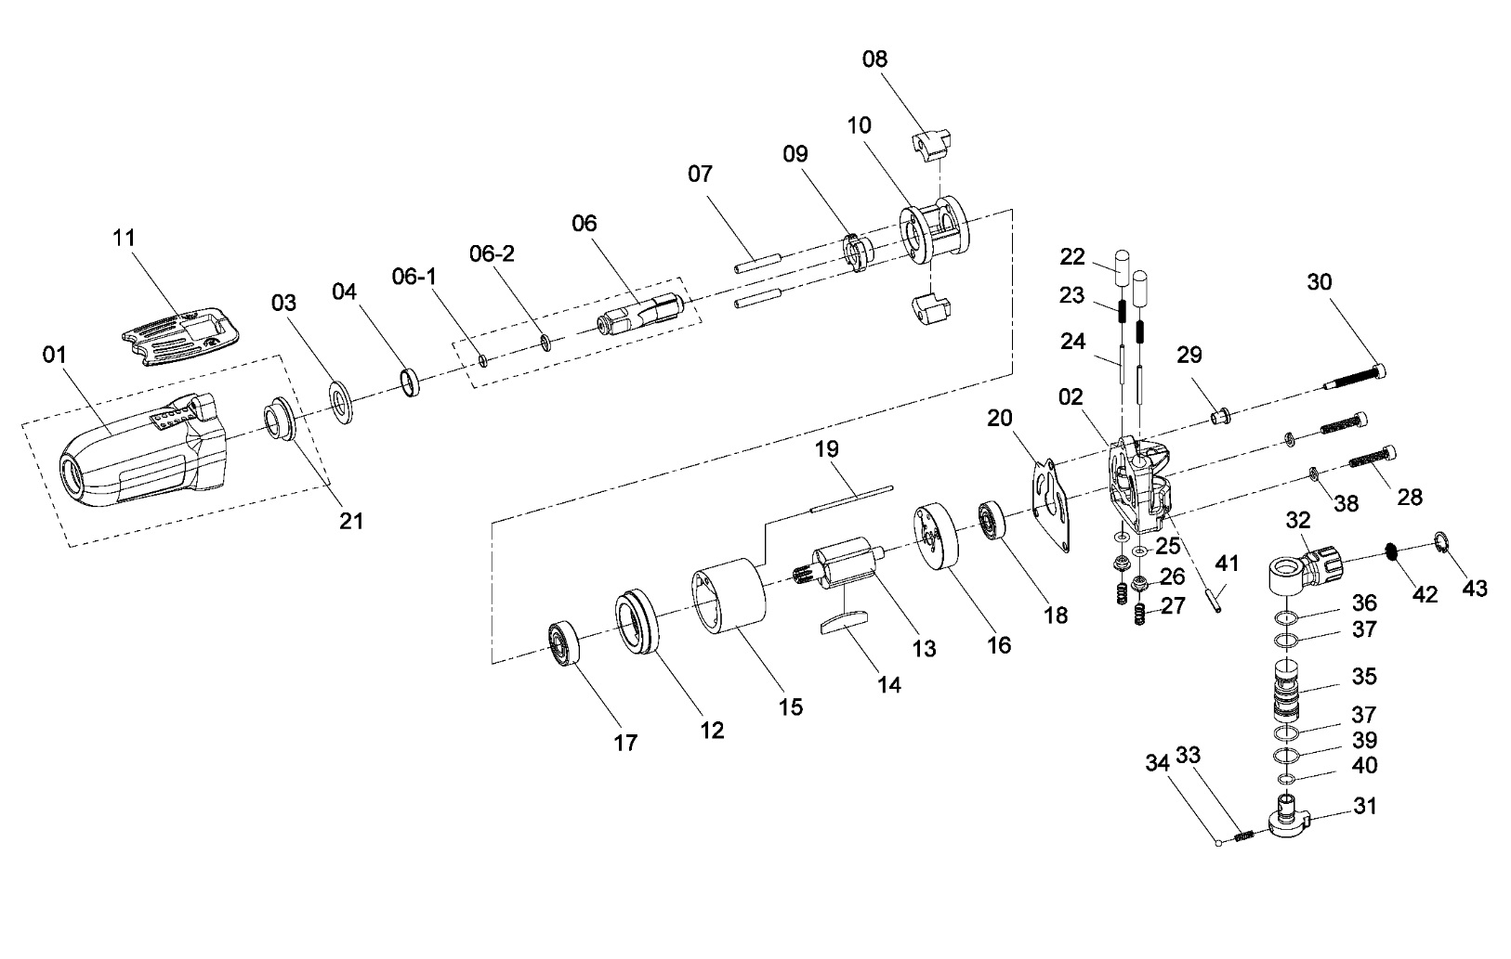

**GP1204**

**Clé à chocs 3/8**

|  |  |  |  |  |  |  |  |
| --- | --- | --- | --- | --- | --- | --- | --- |
| ref. | Rep | Désignation | Qté | ref. | Rep | Désignation | Qté |
| GP1204-1 | 1 | Corps (inclus 21) | 1 | GP1204-2 | 2 | Carter arrière | 1 |
| GP1204KITC | 3 | Rondelle | 1 | GP1204-21 | 21 | Entretoise | 1 |
| 4 | Entretoise | 1 | GP1204KITA | 22 | Poussoir | 2 |
| 6 | Broche | 1 | 23 | Ressort | 2 |
| 6-1 | Jonc | 1 | 24 | Axe | 2 |
| 6-2 | Joint | 1 | 25 | Joint | 2 |
| 7 | Axe marteau | 2 | 26 | Valve | 2 |
| 8 | Marteau | 2 | 27 | Ressort | 2 |
| 9 | Came | 1 | 28 | Vis | 2 |
| 10 | Cage de frappe | 1 | 31 | Variateur | 1 |
| GP1204KITB | 11 | Gâchette | 1 | 32 | Raccord tournant | 1 |
| 14 | Palette | 5 | 33 | Ressort | 1 |
| 17 | Roulement 626-2RS | 1 | 34 | Bille | 1 |
| 18 | Roulement 608-2RS | 1 | 35 | Chemise | 1 |
| 20 | Joint carter arrière | 1 | 36 | Joint | 1 |
| 29 | Entretoise | 1 | 37 | Joint | 2 |
| 30 | Vis | 1 | 38 | Rondelle | 2 |
| GP1204KITD | 12 | Flasque avant | 1 | 39 | Joint | 1 |
| 13 | Rotor | 1 | 40 | Joint | 1 |
| 15 | Chemise moteur | 1 | 41 | Goupille | 1 |
| 16 | Flasque arrière | 1 | 42 | Filtre | 1 |
| 19 | Axe chemise | 1 | 43 | Circlips | 1 |
| RA1250 | 6-1 | Jonc | 1 | GP1204-6.2 | 6-2 | Joint |  |