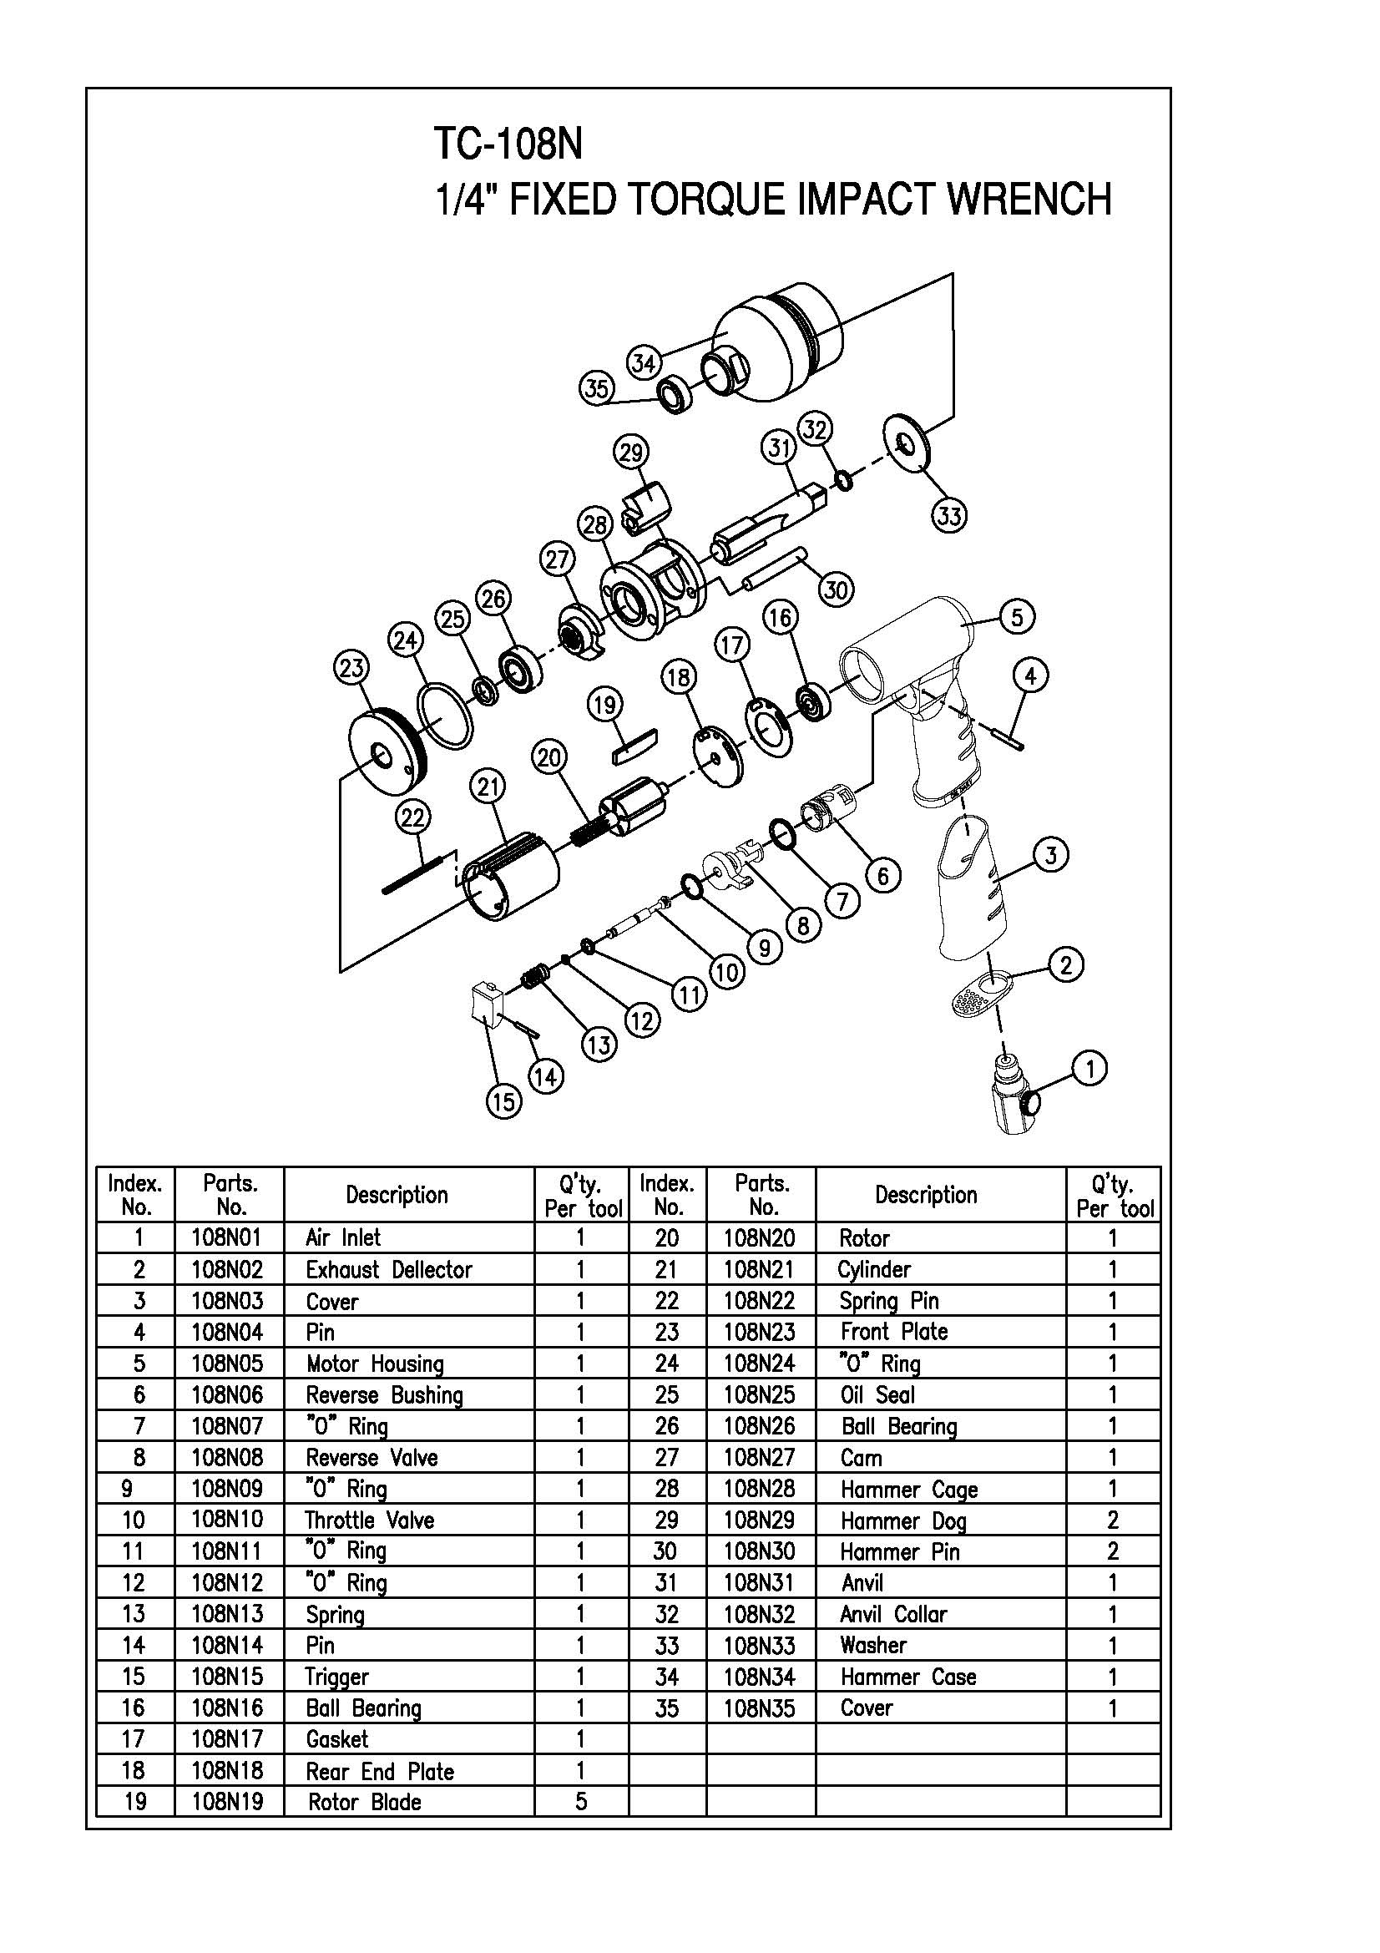

**GP1101BK**

**Clé à chocs 1/4**

|  |  |  |  |  |  |  |  |
| --- | --- | --- | --- | --- | --- | --- | --- |
| Rep | ref. | Désignation | Qté | Rep | ref. | Désignation | Qté |
| 1 | GP1101-1 | Variateur | 1 | 19 | GP1101-20 | Palette | 5 |
| 2 | GP1101-3 | Grille silencieux | 1 | 20 | GP1101-21 | Rotor | 1 |
| 3 | GP1101-4 | Grip poignée | 1 | 21 | GP1101-22 | Chemise | 1 |
| 4 | GP1101-5 | Goupille | 1 | 22 | GP1101-23 | Goupille chemise | 1 |
| 5 | GP1101-6 | Corps | 1 | 23 | GP1101-24 | Flasque Avt | 1 |
| 6 | GP1101-7 | Insert gâchette | 1 | 24 | GP1101-25 | Joint | 1 |
| 7 | GP1101-8 | Joint | 1 | 25 | GP1101-26 | Entretoise | 1 |
| 8 | GP1101-9 | Inverseur | 1 | 26 | GP1101-27 | Roulement | 1 |
| 9 | GP1101-10 | Joint | 1 | 27 | GP1101-28 | Came | 1 |
| 10 | GP1101-11 | Axe gâchette | 1 | 28 | GP1101-29 | Cage de frappe | 1 |
| 11 | GP1101-12 | Joint | 1 | 29 | GP1101-30 | Marteau | 2 |
| 12 | GP1101-13 | Joint | 1 | 30 | GP1101-31 | Axe marteau | 2 |
| 13 | GP1101-14 | Ressort | 1 | 31 | GP1101-32 | Broche | 1 |
| 14 | GP1101-15 | Goupille | 1 | 32 | GP1101-33 | Joint | 1 |
| 15 | GP1101-16 | Gâchette | 1 | 33 | GP1101-35 | Rondelle | 1 |
| 16 | GP1101-17 | Roulement | 1 | 34 | GP1101-36 | Cloche | 1 |
| 17 | GP1101-18 | Joint | 1 | 35 | GP1101-37 | Joint spi | 1 |
| 18 | GP1101-19 | Flasque Arr | 1 |  |  |  |  |